Project Proposal

Prepared for: Capstone project 1(Data Scienc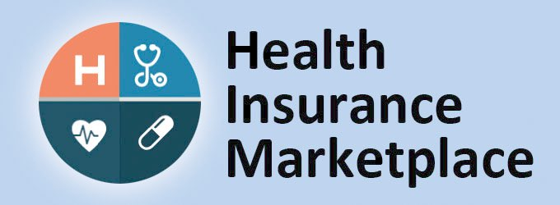e Career Track)

Springboard

Prepared by: Vishal Kumar

September 18, 2017

Proposal number: 1

# Project proposal

## Introduction

A service that helps people shop for and enroll in affordable health insurance. The federal government operates the Marketplace, available at HealthCare.gov, for most states. Some states run their own Marketplaces.

The Health Insurance Marketplace (also known as the “Marketplace” or “exchange”) provides health plan shopping and enrollment services through websites, call centers, and in-person help.

Small businesses can use the Small Business Health Options Program (SHOP) Marketplace to provide health insurance for their employees.

## Goals

Building a model which will help to compare and enroll to the most affordable health plan for an individual or small business. We will try to answer some analytical questions like How do plan rates and benefits vary across states?How do plan benefits relate to plan rates? How do plan rates vary by age? How do plans vary across insurance network providers?

This model can be used by anyone who don’t have health insurance through a job, Medicare, Medicaid, the Children’s Health Insurance Program (CHIP), or another source that provides qualifying health coverage, the Marketplace can help you get covered.

Springboard

Also this model can be used by health insurance providers to improve their sales by comparing the similar plans with their competitors.

## About Data

The dataset going to be used for this project will be download from the kaggle.(link is below).

<https://www.kaggle.com/hhs/health-insurance-marketplace>

This data was originally prepared and released by the Centers for Medicare & Medicaid Services (CMS)

## Project Outline

I will use different Data Science techniques and visualization method to achieve the goals. These methods includes data wrangling, visualization using matplotlib, seaborn etc., statistics, machine learning(ML). All these technique will be used in python for data science.

## Project Deliverables

Report(jupyter notebook): which will have all the codes, plots, links(if necessary), associated word documents.